EXPERIMENT 1

1.# Monthly Sales Data
month <- c("January", "February", "March", "April", "May")
sales <- c(15000, 18000, 22000, 20000, 23000)
# Line Chart
plot(sales,
type = "o",
xaxt = "n",
col = "blue",
pch = 16,
xlab = "Month",
ylab = "Sales ($)",
main = "Monthly Sales Trend")
axis(1, at = 1:5, labels = month)
grid()

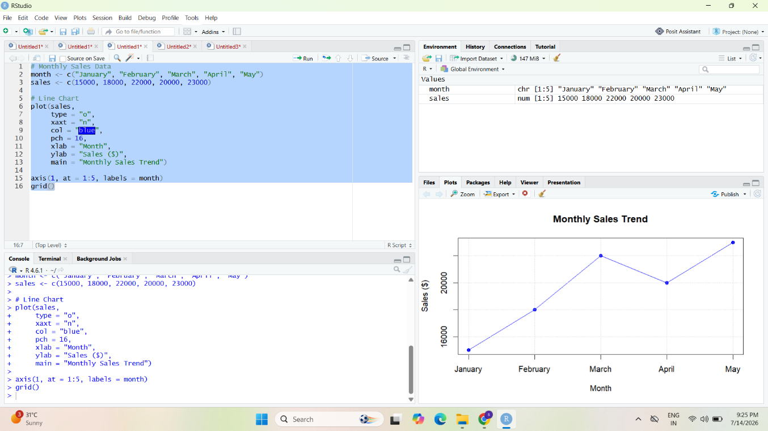
2.# Product Sales Data
products <- c("Product A", "Product B", "Product C", "Product D", "Product E")
sales <- c(320, 450, 280, 510, 390)

# Bar Chart
barplot(sales,
names.arg = products,
col = "skyblue",
xlab = "Products",
ylab = "Units Sold",
main = "Top-Selling Products")

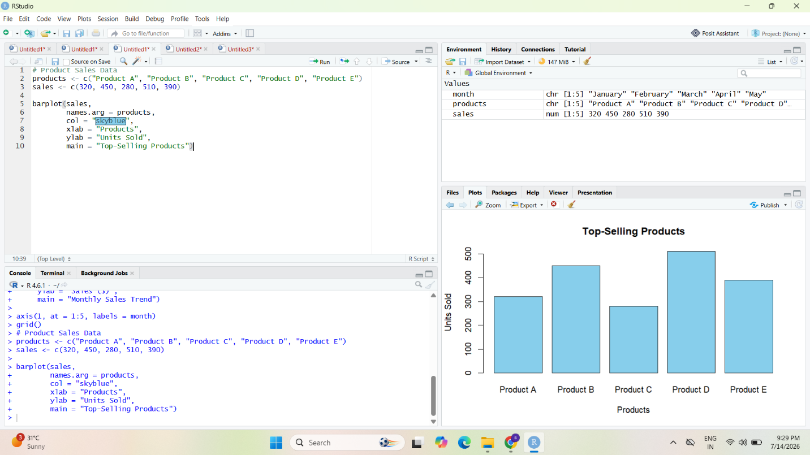

3. # Advertising Budget and Monthly Sales
advertising <- c(500, 700, 900, 850, 1000)
sales <- c(15000, 18000, 22000, 20000, 23000)
# Scatter Plot
plot(advertising,
sales,
pch = 19,
col = "red",
xlab = "Advertising Budget ($)",
ylab = "Monthly Sales ($)",
main = "Advertising Budget vs Sales")
# Regression Line
abline(lm(sales ~ advertising), col = "blue", lwd = 2)

